Multiple Choice
Identify the letter of the choice that best completes the statement or answers the question.

____ 1. Tripling the amplitude of a wave will change the magnitude of the waves energy by what factor?
a. | one-third | c. | 3
b. | 1 | d. | 9

____ 2. A mass attached to a spring vibrates back and forth. At the equilibrium position, the
a. | the acceleration reaches a maximum. | c. | net force reaches a maximum.
b. | velocity reaches a maximum. | d. | velocity reaches zero.

____ 3. A mass attached to a spring vibrates back and forth. At maximum displacement, the spring force and the
a. | velocity reach a maximum. | c. | acceleration reach a maximum.
b. | velocity reach zero. | d. | acceleration reach zero.

____ 4. If a force of 50 N stretches a spring 0.10 m, what is the spring constant?
a. | 5 N/m | c. | –5 N/m
b. | 500 N/m | d. | –500 N/m

____ 5. A 0.20 kg mass suspended from a spring moves with simple harmonic motion. At the instant the mass is displaced from equilibrium by –0.05 m, what is its acceleration? (The spring constant is 10.0 N/m.)
a. | 1200 m/s² | c. | 0.10 m/s²
b. | 41 m/s² | d. | 2.5 m/s²

____ 6. How much displacement will a coil spring with a spring constant of 120 N/m achieve if it is stretched by a 60 N force?
a. | –0.5 m | c. | –4 m
b. | –2 m | d. | –7000 m

____ 7. A mass on a spring that has been compressed 0.1 m has a restoring force of 20 N. What is the spring constant?
a. | 10 N/m | c. | 200 N/m
b. | 20 N/m | d. | 300 N/m

____ 8. The angle between the string of a pendulum at its equilibrium position and at its maximum displacement is its
a. | period. | c. | vibration.
b. | frequency. | d. | amplitude.

____ 9. For a mass hanging from a spring, the maximum displacement the spring is stretched or compressed from its equilibrium position is its
a. | amplitude. | c. | frequency.
b. | period. | d. | acceleration.

____ 10. A pendulum swings through a total of 28°. If the displacement is equal on each side of the equilibrium position, what is the amplitude of this vibration? (Disregard frictional forces acting on the pendulum.)
a. | 28⁰ | c. | 56⁰
b. | 14⁰ | d. | 7.0⁰

____ 11. Which of the following is the time it takes to complete a cycle of motion?
a. | amplitude | c. | frequency
b. | period | d. | revolution

____ 12. Which of the following is the number of cycles or vibrations per unit of time?
a. | amplitude | c. | frequency
b. | period | d. | revolution

____ 13. How are frequency and period related in simple harmonic motion?
a. | They are directly related.
b. | They are inversely related.
c. | They both measure the time per cycle.
d. | They both measure the number of cycles per unit of time.

____ 14. An amusement park ride has a frequency of 0.05 Hz. What is the ride’s period?
a. | 5 s | c. | 20 s
b. | 10 s | d. | 40 s

____ 15. An amusement park ride swings back and forth once every 40.0 s. What is the ride’s frequency?
a. | 2.50 · 10^{–2} Hz | c. | 25.0 · 10^{–2} Hz
b. | 5.00 · 10^{–2} Hz | d. | 40.0 · 10^{–2} Hz

____ 16. A mass on a spring vibrates in simple harmonic motion at an amplitude of 8.0 cm. If the mass of the object is 0.20 kg and the spring constant is 130 N/m, what is the frequency?
a. | 1.5 Hz | c. | 4.0 Hz
b. | 8.7 Hz | d. | 1.6 Hz

____ 17. A car with bad shock absorbers bounces up and down with a period of 1.5 s after hitting a bump. The car has a mass of 1500 kg and is supported by four springs with a spring constant of 6600 N/m. What is the period for each spring?
a. | 1.5 s | c. | 4.4 s
b. | 5.8 s | d. | 3.6 s

____ 18. What is the period of a 4.12 m long pendulum?
a. | 2.01 s | c. | 4.07 s
b. | 3.11 s | d. | 9.69 s

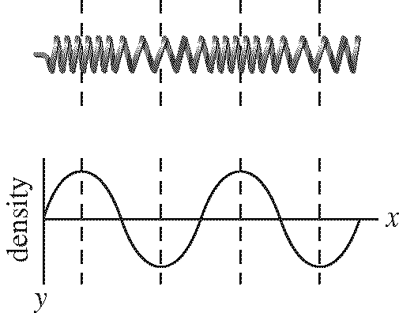

____ 19. In the waveform of the longitudinal wave shown above, the compressed regions correspond to
a. | the wavelength. | c. | troughs.
b. | crests. | d. | the mass.

____ 20. In the waveform of the longitudinal wave shown above, the stretched regions correspond to
a. | the wavelength. | c. | troughs.
b. | crests. | d. | the mass.

____ 21. A periodic wave has a wavelength of 0.50 m and a speed of 20 m/s. What is the wave frequency?
a. | 0.02 Hz | c. | 40 Hz
b. | 20 Hz | d. | 10 Hz

____ 22. Which of the following is the interference that results when individual displacements on opposite sides of the equilibrium position are added together to form the resultant wave?
a. | constructive | c. | complete constructive
b. | destructive | d. | complete destructive

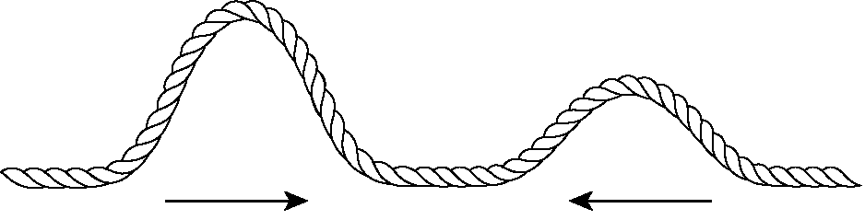

____ 23. Which of the following types of interference will occur in the figure above?
a. | partial constructive | c. | complete constructive
b. | partial destructive | d. | complete destructive

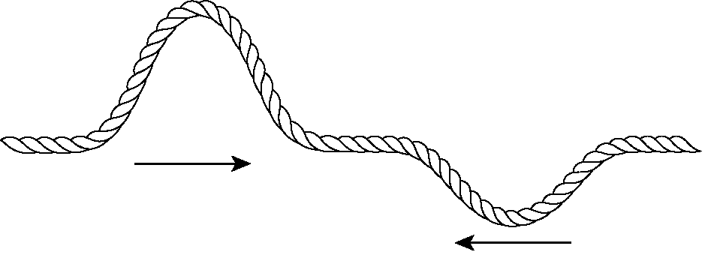

____ 24. Which of the following types of interference will occur in the figure above?
a. | partial constructive | c. | complete constructive
b. | partial destructive | d. | complete destructive

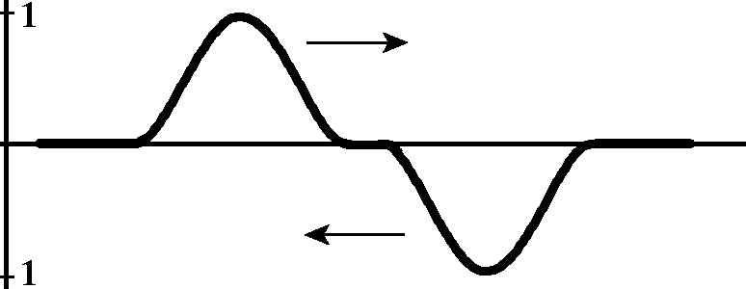

____ 25. Which of the following types of interference will occur in the figure above if the crest and trough hit the same point simultaneously?
a. | partial constructive | c. | complete constructive
b. | partial destructive | d. | complete destructive

____ 26. At a fixed boundary, waves are
a. | neither reflected nor inverted. | c. | reflected and inverted.
b. | reflected but not inverted. | d. | inverted but not reflected.

____ 27. At a free boundary, waves are
a. | neither reflected nor inverted. | c. | reflected and inverted.
b. | reflected but not inverted. | d. | inverted but not reflected.

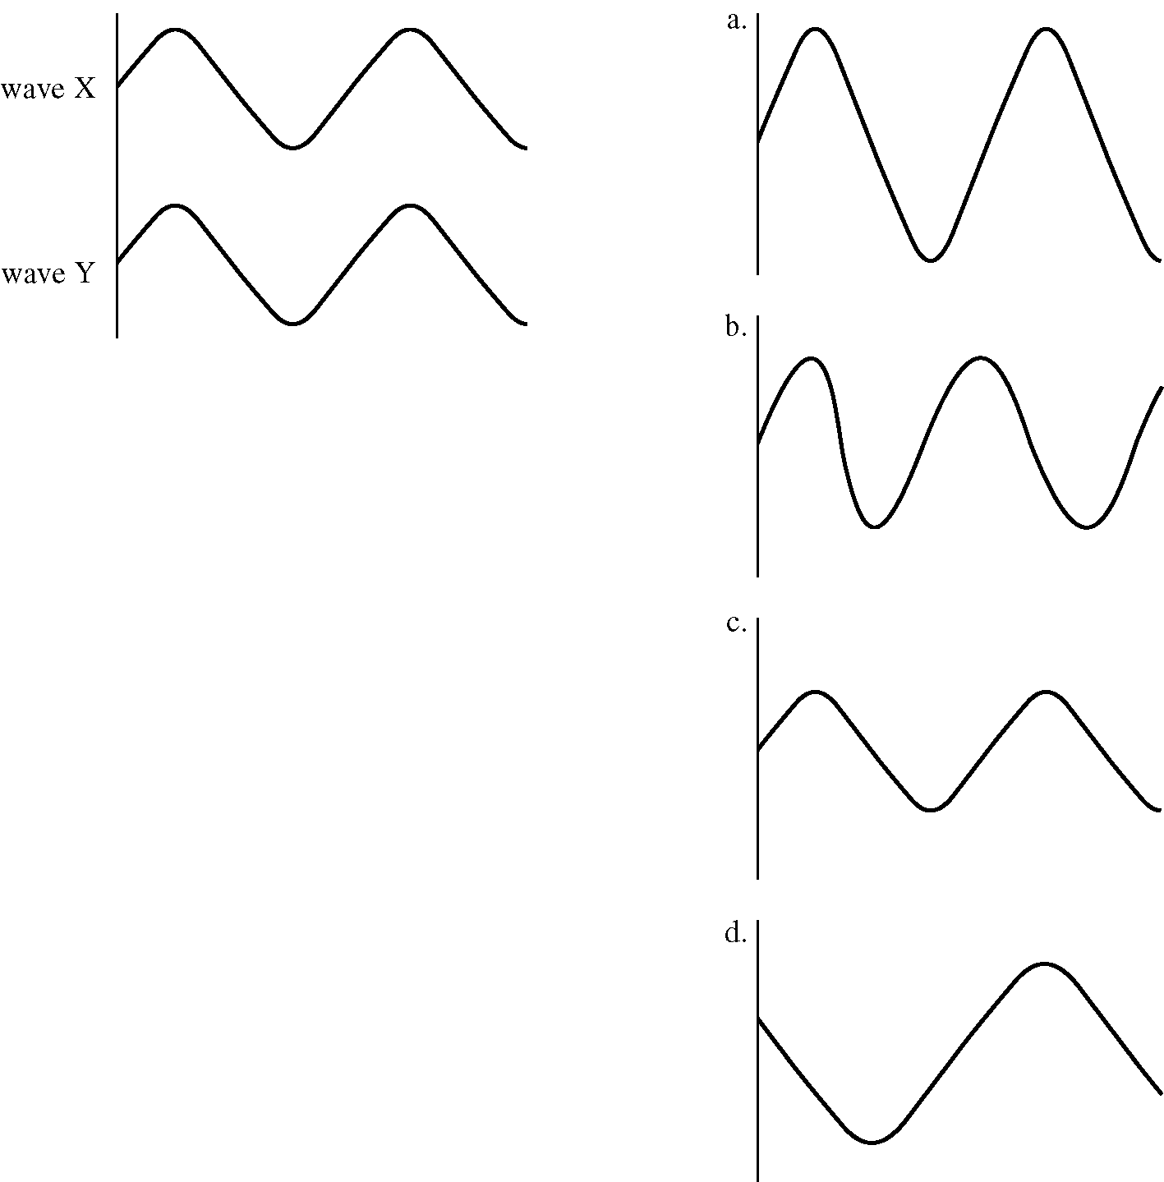

____ 28. In the diagram above, use the superposition principle to find the resultant wave of waves X and Y. (X & Y are identical, if that helps…)
a. | a | c. | c
b. | b | d. | d

Short Answer

29. What is simple harmonic motion?

30. How is the relationship between period and frequency represented as an equation?

31. Explain how particles in a medium are related to waves.

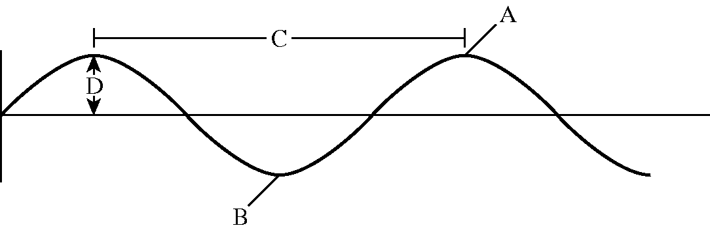

32. In the waveform shown above, which letter represents the amplitude of the wave?

33. In the waveform shown above, which letter represents the trough of the wave?

34. In the waveform shown above, what does letter C represent?

35. What happens to the energy of a wave when the amplitude is increased?
Chapter 12: Simple Harmonic Motion
Answer Section

MULTIPLE CHOICE

1. C

2. B

3. C

4. B

5. D

6. A

7. C

8. D

9. A

10. B

11. B

12. C

13. B

14. C

15. A

16. C

17. A

18. C

19. B

20. C

21. C

22. B

23. A

24. B

25. D

26. C

27. B

28. A

SHORT ANSWER

29. Simple harmonic motion is vibration about an equilibrium position in which a restoring force is proportional to the displacement from equilibrium.

30. 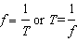

31. A medium is a material through which a disturbance travels, and some waves cannot exist without it. The medium provides the particles that vibrate about an equilibrium position, that is, the particles through which a wave passes.

32. D

33. B

34. wavelength

35. The energy increases.

